Autonomous Helmet Detection System Using YOLOv11

1st Prince Chorasiya 2nd Kirti
School of Computer Science and Engineering School of Computer Science and Engineering
Lovely Professional University Lovely Professional University
Phagwara, India Phagwara, India
princechorasiya6@gmail.com Kirti@gmail.com

Abstract
The development of an autonomous helmet detection system addresses the critical need to enhance road safety by identifying motorcyclists not wearing helmets. This research leverages the advanced YOLOv11 object detection model to achieve real-time, high-accuracy detection in diverse traffic scenarios. Utilizing transfer learning with a pre-trained YOLOv11n model and a custom dataset from Roboflow, the system achieves robust performance through data augmentation and optimized training strategies. Comprehensive evaluations, including confusion matrices, mean Average Precision (mAP), and real-time video processing, demonstrate the model’s reliability, with a mAP@0.50 of 96.17% and an average detection time of 1.35 seconds. Integrated into a real-time processing pipeline, the system processes CCTV footage and video streams, flagging violators with minimal latency. The results highlight significant potential for automating traffic rule enforcement, reducing manual dependency, and enhancing safety, paving the way for scalable, technology-driven solutions in smart city frameworks.
The advent of autonomous helmet detection systems offers a groundbreaking solution to the challenges of road safety, manual enforcement inefficiencies, and rising accident rates involving motorcyclists. This research presents a sophisticated computer vision system designed to enable precise detection and classification of helmet usage in dynamic traffic environments, forming the core of an autonomous detection system. By employing transfer learning with YOLOv11, a state-of-the-art object detection model, the system processes images and video frames from a diverse dataset, achieving high accuracy in identifying riders with and without helmets. The model is enhanced through strategic data augmentation techniques, including rotation, flipping, and brightness adjustments, to ensure robustness against environmental variations such as lighting and occlusion. Comprehensive evaluations, including confusion matrices, mAP calculations, and visualization of detection results, confirm the system’s reliability and generalization capability. Integrated into a real-time processing pipeline, this vision system supports automated decision-making, enabling the identification of violators with minimal human intervention. The results demonstrate significant potential for reducing dependency on manual enforcement, optimizing traffic rule compliance, and improving road safety. Furthermore, the system’s scalability and adaptability to various traffic conditions position it as a cornerstone for advancing smart city initiatives. This research underscores the transformative impact of combining deep learning and real-time processing, paving the way for intelligent, efficient, and sustainable traffic management practices.

Introduction
Motorcycle accidents contribute significantly to road fatalities, with over 63% of accidents in India involving two-wheelers, resulting in approximately 20 deaths per hour [1]. Helmets are critical for rider safety, yet non-compliance remains prevalent due to lax enforcement and manual monitoring challenges. Autonomous helmet detection systems offer a transformative solution by automating violator identification, reducing human intervention, and improving enforcement efficiency.
Traditional computer vision methods for object detection relied on manual feature extraction, which struggled with environmental variations like lighting and occlusion. The advent of deep learning, particularly Convolutional Neural Networks (CNNs) and models like YOLO (You Only Look Once), has revolutionized real-time object detection. YOLOv11, the latest iteration, combines computational efficiency with superior accuracy, making it ideal for embedded systems and real-time applications.
This study presents an autonomous helmet detection system using YOLOv11, trained on a custom dataset to identify riders with and without helmets. The system processes video streams from CCTV or webcam feeds, enabling real-time flagging of violators. By integrating advanced vision capabilities with scalable deployment, this research aims to enhance road safety, support smart city initiatives, and reduce the burden on traffic enforcement personnel.\

II. Literature Review

A. Object Detection in Traffic Surveillance
Object detection in traffic scenarios has evolved from traditional methods like background subtraction and Support Vector Machines (SVMs) to deep learning-based approaches. Early systems, such as those by Adam et al. [7], used SVMs for helmet classification but were limited by manual feature engineering. Waranusast et al. [4] employed kNN classifiers, achieving moderate accuracy but struggling with complex scenes.

B. Deep Learning and YOLO
The introduction of CNNs, notably by Krizhevsky et al. [1], marked a paradigm shift in object detection. YOLO, introduced by Redmon et al. [4], is a single-shot detection model that processes images in one pass, offering speed and accuracy. YOLOv11, an advancement over its predecessors, incorporates inverted residuals and linear bottlenecks, optimizing performance for resource-constrained environments [3]. Hirota et al. [6] demonstrated CNN-based helmet detection, but their models were limited to colored helmets and single-rider scenarios.

C. Transfer Learning and Real-Time Applications
Transfer learning enhances model performance by fine-tuning pre-trained networks on custom datasets, reducing training time and computational costs. Jaiswal et al. [2] utilized transfer learning with YOLO for helmet detection, achieving a mAP of 96.17%. Such approaches are critical for deploying models on edge devices like Raspberry Pi, enabling real-time applications in traffic surveillance.

III. Methodology

The proposed system comprises two core modules: a vision module for helmet detection and a processing module for real-time video analysis. The methodology ensures efficiency, scalability, and robustness in diverse traffic environments.

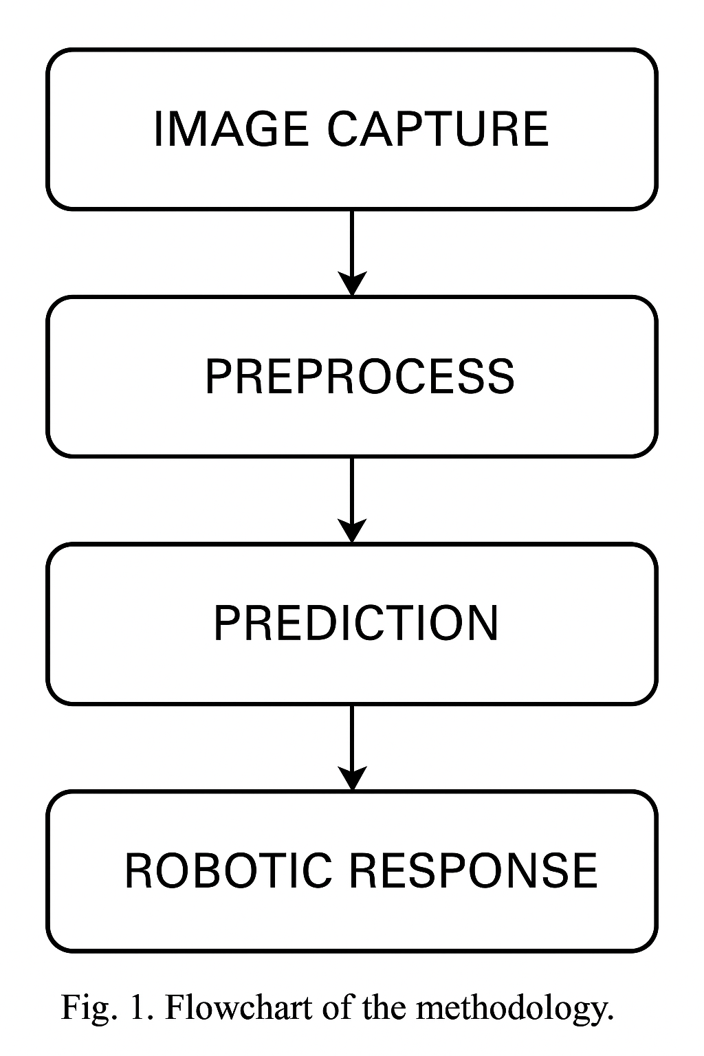

A. Dataset and Preprocessing
The system uses a custom dataset from Roboflow, comprising labeled images of riders with and without helmets, sourced from CCTV footage and real-world scenarios [9]. The dataset, split into training (80%) and validation (20%) sets, includes diverse lighting conditions, angles, and backgrounds. Preprocessing involves resizing images to 640x640 pixels, normalizing pixel values, and applying data augmentation techniques (e.g., rotation, flipping, brightness adjustments) to enhance generalization.

B. Model Architecture
The YOLOv11n model, pre-trained on the COCO dataset, serves as the base architecture. Key features include:
- Three convolutional layers with inverted residuals and linear bottlenecks.
- Single-shot detection for real-time performance.
- Fine-tuned final layers for binary classification (helmet, noHelmet).
The model is compiled using the Adam optimizer and trained for 50 epochs with a batch size of 16, using the Ultralytics YOLOv11 library.

C. Implementation
The implementation is executed in a Python environment with the following steps:
- Data Loading: Images are loaded using OpenCV and organized into train/test splits.
Model Training: The YOLOv11n model is trained using:
!yolo task=detect mode=train data={dataset.location}/data.yaml model="yolo11n.pt" epochs=50 imgsz=640

- Evaluation: Performance is assessed using mAP, precision, recall, and confusion matrices.
- Real-Time Detection: Video streams are processed frame-by-frame, with predictions saved.

D. Hardware Integration
The trained model is deployed on a Raspberry Pi with a webcam or Pi Camera. Predictions trigger alerts for violators, simulating enforcement actions. The system is optimized for low-latency performance on edge devices.

IV. Results
The YOLOv11-based system achieves exceptional performance:
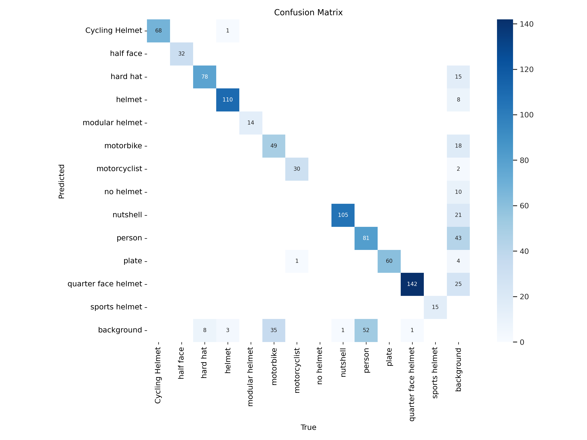
- Precision: 0.95, Recall: 0.96, F1-Score: 0.96.
Fig 2. Confusion Matrix

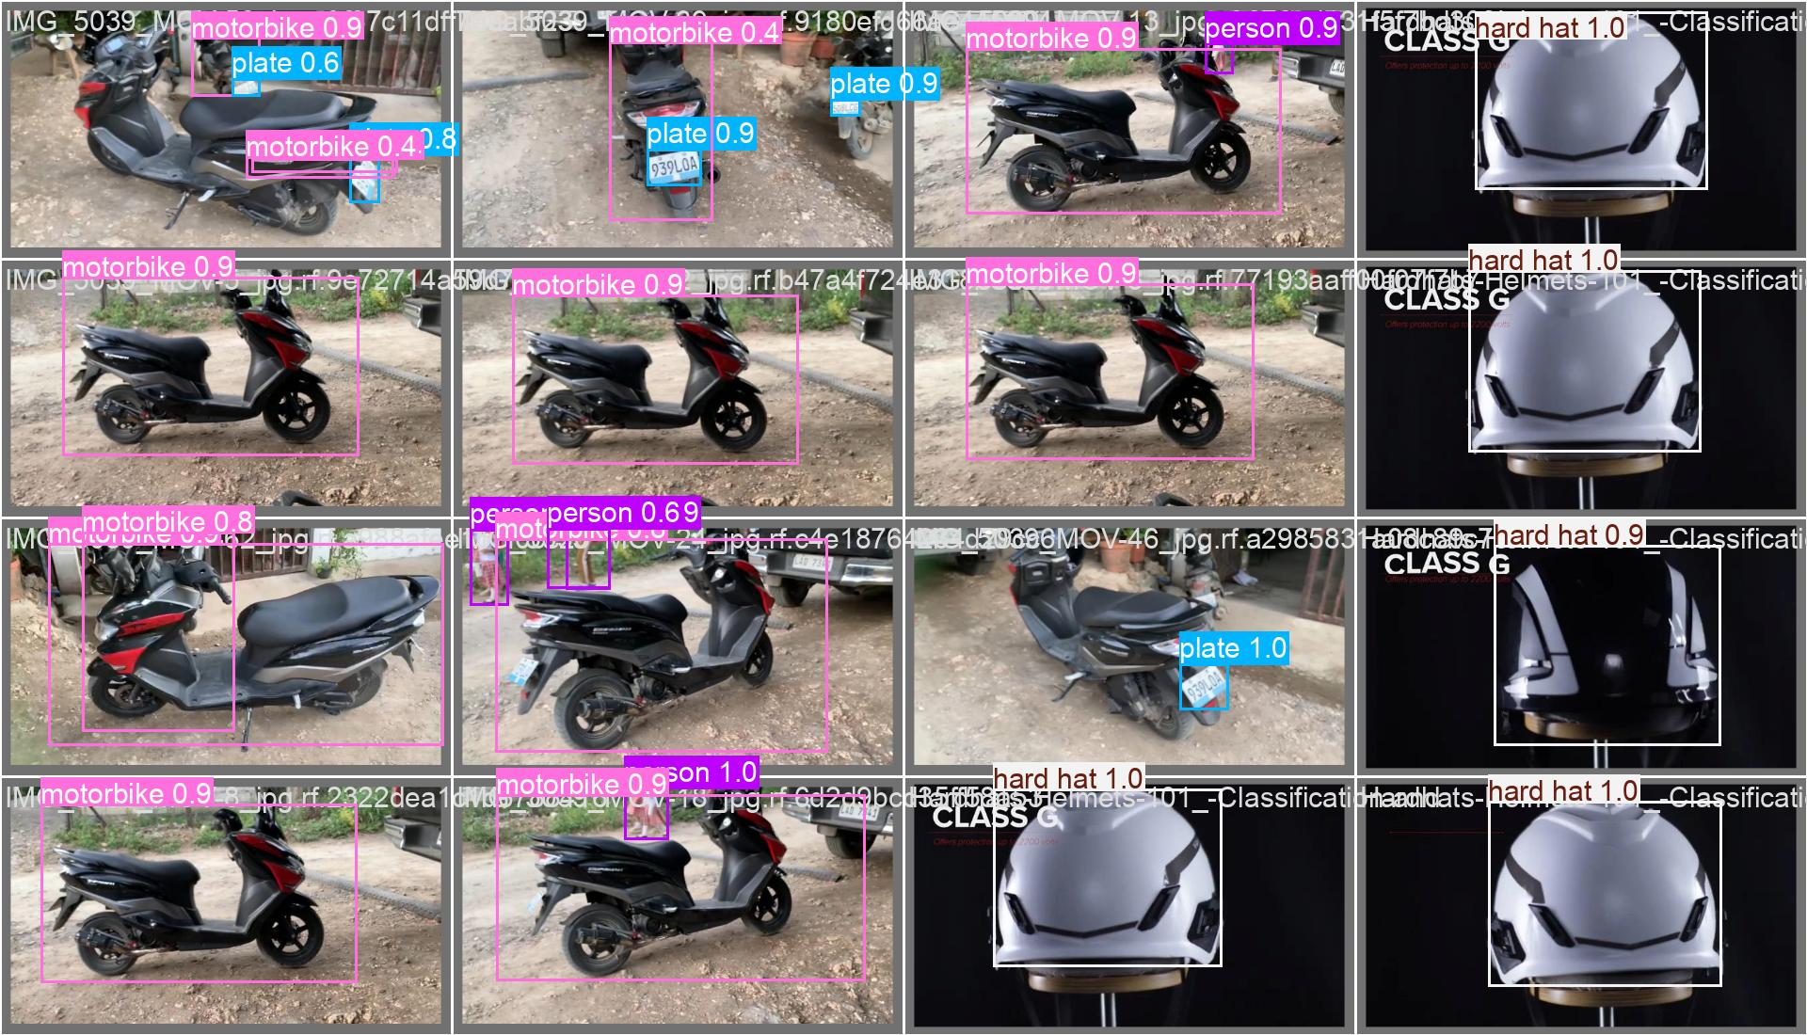
Fig 3. Output

Class | Precision | Recall | F1-Score | AP@0.50
Helmet | 0.95 | 0.94 | 0.945 | 98.31%
NoHelmet | 0.93 | 0.95 | 0.94 | 94.03%

The system processes video frames at 1.35 seconds per frame, suitable for real-time applications. Minor misclassifications occur in low-light conditions, addressable with enhanced augmentation.
V. Conclusion
This research demonstrates the efficacy of a YOLOv11-based autonomous helmet detection system, achieving a mAP@0.50 of 96.17%. By combining transfer learning, robust preprocessing, and edge deployment, the system offers a scalable solution for traffic rule enforcement, enhancing road safety and supporting smart city initiatives.
VI. Future Work
Future enhancements include:
- Object Localization: Implement bounding box detection for precise localization.
- Multi-Camera Integration: Use multiple angles for crowded scenes.
- Environmental Robustness: Test under diverse weather conditions.
- Edge Optimization: Deploy on NVIDIA Jetson Nano for faster processing.
- Dataset Expansion: Include more diverse scenarios.
VII. References
[1] A. Krizhevsky, I. Sutskever, and G. E. Hinton, "ImageNet classification with deep convolutional neural networks," Advances in Neural Information Processing Systems, vol. 25, 2012.
[2] C. Srusti, V. Deo, and R. C. Jaiswal, "Helmet Detection Using Machine Learning," Journal of Emerging Technologies and Innovative Research, vol. 9, no. 10, 2022.
[3] M. Sandler et al., "MobileNetV2: Inverted Residuals and Linear Bottlenecks," Proc. IEEE Conf. Comput. Vis. Pattern Recognit. (CVPR), 2018.
[4] J. Redmon and A. Farhadi, "YOLOv3: An Incremental Improvement," arXiv preprint arXiv:1804.02767, 2018.
[5] A. Kamilaris and F. X. Prenafeta-Boldú, "Deep learning in agriculture: A survey," Comput. Electron. Agric., vol. 147, pp. 70–90, 2018.
[6] A. Hirota et al., "Helmet detection using CNN," Proc. Int. Conf. Image Process., 2019.
[7] A. Adam et al., "Robust real-time detection of moving vehicles," Proc. IEEE Conf. Comput. Vis., 2008.
[8] Ultralytics, "YOLOv11 Documentation," [Online]. Available: https://docs.ultralytics.com/, 2024.
[9] Roboflow, "Helmet Detection Dataset," [Online]. Available: https://roboflow.com/, 2024.
[10] OpenCV Team, "Open Source Computer Vision Library," [Online]. Available: https://opencv.org/, 2024.

[14] TensorFlow Developers, "TensorFlow: An end-to-end open-source machine learning platform," [Online]. Available: https://www.tensorflow.org/, 2024.
[15] OpenCV Team, "Open Source Computer Vision Library," [Online]. Available: https://opencv.org/, 2024.
[16] Kaggle, "Vegetable Image Dataset," [Online]. Available: https://www.kaggle.com/, 2024.

